Four Weeks Industrial Training Project Report

on

Hospital Information System

Submitted in the partial fulfillment of the requirement for the award of degree of

Bachelor of Technology

in

Computer Science and Engineering

Batch (2020-2024)



## Submitted to Submitted by:

Dr. Naveen Bilandi Manpreet Singh Training and Placement Head (CSE ) 12000446

## DEPARTMENT OF COMPUTER SCIENCE AND ENGINEERING DAV UNIVERSITY

**JALANDHAR-PATHANKOT NATIONAL HIGHWAY, NH 44, SARMASTPUR PUNJAB**

**144012**

# ACKNOWLEDGEMENT

I express my gratitude to all those who helped us in various stages of the development of this project. First, I would like to express my sincere gratitude indebtedness to Dr.

Jasbir Rishi (Vice-Chancellor), Dr.R K Seth (Dean Academics ) and Mr. Sanjeev Dhiman ( Coordinator, Head of Department ,Computer Science and Engineering) and Dr. Naveen Bilandi (Training and Placementy Head ) DAV University for allowing me to undergo the summer training of four weeks at …………………………………

I am also thankful to all faculty members of Department of Computer Science and Engineering, for their true help, inspiration and for helping me for the preparation of the final report and presentation.

Last but not least, I pay my sincere thanks and gratitude to all the Staff Members of ………………… for their support and for making our training valuable and fruitful.

# DECLARATION

I, MANPREET SINGH, hereby declare that the work which is being presented in this project/training titled “Hospital Information System” by me, in partial fulfillment of the requirements for the award of Bachelor of Technology (B.Tech) Degree in “Computer Science and Engineering” is an authentic record of my own work carried out under the guidance of Mr…………….. (Name and Designation of Trainer).

To the best of my knowledge, the matter embodied in this report has not been submitted to any other University/ Institute for the award of any degree or diploma.

MANPREET SINGH

12000446

Dr. Naveen Bilandi

(Training and Placement Head, CSE )

# CERTIFICATE

This is to certify that Mr. Ratnesh Kumar Ratan has completed Industrial Training during the period from 26 July 2021 to 10 September 2021 in our Organization / Industry as a Partial Fulfilment of Degree of Bachelor of Technology in Computer Science and Engineering. He / She was trained in the field of Python and Machine Learning.

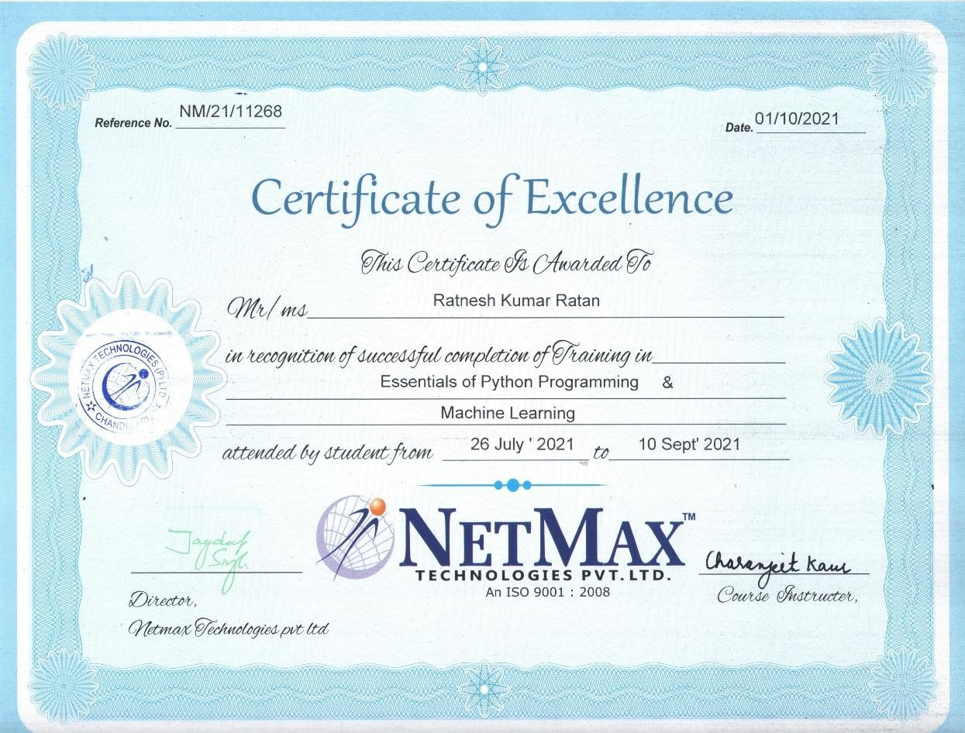

# Table of Content

## Abstract 06

## Introduction 07

## Project Title and Overview 12

* 1. Company Profile 12
  2. Methodologies 12

1. **13**
   1. Hardware Used 13
   2. Software Used 13

## System Design & Development 14

* 1. GUI Design 14
  2. Model Training Code 18
  3. GUI & Event Code 20

## User Manual 22

1. **Reference 24**

# ABSTRACT

The purpose of project entitled as “Hospital Information System” is to computerized the front office of hospital to develop software which is user friendly simple, fast and cost-effective. It deals with the collection of add doctor, patient and create appointments & also manage doctor patient etc. Traditionally, it was done manually. The main functions of system are registred & store patient details & doctor details and retrieve these details as and when required.

The Hospital information system can be entered using a user name & password. It is accessible by an admin, doctor and receptionist. Only they can add data into database. The data can retrieve easily. The data are well protected and secure from unauthorized users and makes the data very fast. Computer is not only used to increase the efficiency in all fields ranging from fixing appointment with the doctor to keeping the record of patient.

.

# Introduction

Machine Learning is the science of getting computers to learn without being explicitly programmed. It is closely related to computational statistics, which focuses on making prediction using computer. In its application across business problems, machine learning is also referred as predictive analysis. Machine Learning is closely related to computational statistics. Machine Learning focuses on the development of computer programs that can access data and use it to learn themselves. The process of learning begins with observations or data, such as examples, direct experience, or instruction, in order to look for patterns in data and make better decisions in the future based on the examples that we provide. The primary aim is to allow the computers learn automatically without human intervention or assistance and adjust actions accordingly.

## History of Machine Learning

The name machine learning was coined in 1959 by Arthur Samuel. Tom M. Mitchell provided a widely quoted, more formal definition of the algorithms studied in the machine learning field: "A computer program is said to learn from experience E with respect to some class of tasks T and performance measure P if its performance at tasks in T, as measured by P, improves with experience E." This follows Alan Turing's proposal in his paper "Computing Machinery and Intelligence", in which the question "Can machines think?" is replaced with the question "Can machines do what we (as thinking entities) can do?". In Turing’s proposal the characteristics that could be possessed by a thinking machine and the various implications in constructing one are exposed.

## Types of Machine Learning

The types of machine learning algorithms differ in their approach, the type of data they input and output, and the type of task or problem that they are intended to solve. Broadly Machine Learning can be categorized into four categories.

### Supervised Learning

1. **Unsupervised Learning**

### Reinforcement Learning

Semi-supervised Learning Machine learning enables analysis of massive quantities of data. While it generally delivers faster, more accurate results in order to identify profitable opportunities or dangerous risks, it may also require additional time and resources to train it properly.

## Supervised Learning

Supervised Learning is a type of learning in which we are given a data set and we already know what are correct output should look like, having the idea that there is a relationship between the input and output. Basically, it is learning task of learning a function that maps an input to an output based on example input-output pairs. It infers a function from labeled training data consisting of a set of training examples. Supervised learning problems are categorized

## Unsupervised Learning

Unsupervised Learning is a type of learning that allows us to approach problems with little or no idea what our problem should look like. We can derive the structure by clustering the data based on a relationship among the variables in data. With unsupervised learning there is no feedback based on prediction result. Basically, it is a type of self-organized learning that helps in finding previously unknown patterns in data set without pre-existing label.

## Reinforcement Learning

Reinforcement learning is a learning method that interacts with its environment by producing actions and discovers errors or rewards. Trial and error search and delayed reward are the most relevant characteristics of reinforcement learning. This method allows machines and software agents to automatically determine the ideal behavior within a specific context in order to maximize its performance. Simple reward feedback is required for the agent to learn which action is best.

## Semi-Supervised Learning

Semi-supervised learning fall somewhere in between supervised and unsupervised learning, since they use both labeled and unlabeled data for training typically, a small amount of labeled data and a large amount of unlabeled data. The systems that use this method are able to considerably improve learning accuracy. Usually, semi-supervised learning is chosen when the acquired labeled data requires skilled and relevant resources in order to train it / learn from it. Otherwise, acquiring unlabeled data generally doesn’t require additional resources.

## Literature Survey

A core objective of a learner is to generalize from its experience. The computational analysis of machine learning algorithms and their performance is a branch of theoretical computer science known as computational learning theory. Because training sets are finite and the future is uncertain, learning theory usually does not yield guarantees of the performance of algorithms. Instead, probabilistic bounds on the performance are quite common. The bias-variance decompositions one way to quantify generalization error. For the best performance in the context of generalization, the complexity of the hypothesis should match the complexity of the function underlying the data. If the hypothesis is less complex than the function, then the model has underfit the data. If the complexity of the model is increased in response, then the training error decreases. But if the hypothesis is too complex, then the model is subject to overfitting and generalization will be poorer.

In addition to performance bounds, learning theorists study the time complexity and feasibility of learning. In computational learning theory, a computation is considered feasible if it can be done in polynomial time. There are two kinds of time complexity results. Positive results show that a certain class of functions can be learned in polynomial time. Negative results show that certain classes cannot be learned in polynomial time.

## The Challenges Facing Machine Learning

While there has been much progress in machine learning, there are also challenges. For example, the mainstream machine learning technologies are black-box approach us making concerned their potential risks. To tackle this challenge, we may want to make machine learning more explainable and controllable. As another example, the computational complexity of machine learning algorithms is usually very high and we may want to invent lightweight algorithms or implementations. Furthermore, in many domains such as physics, chemistry, biology, and social sciences, people usually seek elegantly simple equations (e.g., the Schrödinger equation) to uncover the underlying laws behind various phenomena. Machine learning takes much more time. You have to gather and prepare data, then train the algorithm. There are much more uncertainties. That is why, while in traditional website or application development an experienced team can estimate the time quite precisely, a machine learning project used for example to provide product recommendations can take much less or much more time than expected. Why? Because even the best machine learning engineers don’t know how the deep learning networks will behave when analyzing different sets of data. It also means that the machine learning engineers and data scientists cannot guarantee that the training process of a model can be replicated.

## Applications of Machine Learning

Machine learning is one of the most exciting technologies that one would have ever come across. As it is evident from the name, it gives the computer that which makes it more similar to humans: The ability to learn. Machine learning is actively being used today, perhaps in many more places than one would expect. We probably use a learning algorithm dozen of time without even knowing it. Applications of Machine Learning include:

### Web Search Engine:

One of the reasons why search engines like Google, Bing etc. work so well is because the system has learnt how to rank pages through a complex learning algorithm.

### Photo tagging Applications:

Be it Facebook or any other photo tagging application, the ability to tag friends makes it even more happening. It is all possible because of a face recognition algorithm that runs behind the application.

### Spam Detector:

Our mail agent like Gmail or Hotmail does a lot of hard work for us in classifying the mails and moving the spam mails to spam folder. This is again achieved by a spam classifier running in the back end of mail application.

# Life Expectancy Prediction Using Machine Learning

## Company Profile

Netmax Technologies offer an amazing training place, fantastic features and remarkable opportunity for advancement. They have the successful, growing considerably and up-to-date technology and knowledge. They have an incredibly talented and skilled team. What makes them a cohesive team is their interest and passion for what they do and training Guides objective to help others. They have devoted team for the learner's placement support. By providing professional and trained instructors who are best at effective delivery of course, they prepare the learners for their job.

## Objectives

* + Main objectives of training were to learn:
  + How to determine and measure program complexity,
  + Python Programming
  + ML Library Scikit, NumPy, Matplotlib, Pandas.
  + Statistical Math for the Algorithms.
  + Learning to solve statistics and mathematical concepts.
  + Supervised and Unsupervised Learning
  + Classification and Regression
  + ML Algorithms
  + Machine Learning Programming and Use Cases.

## Methodologies

There were several facilitation techniques used by the trainer which included question and answer, brainstorming, group discussions, case study discussions and practical implementation. After the completion of course every trainee was assigned a project to be submitted. Certificates of completion were distributed among the participants at the end.

**The Hardware used:**

# System Implementation

While developing the system, the used hardware is:

* + Laptop with intel i7 10th gen processor with 16GB ram.

## The Software's used:

* + Microsoft Windows 11 Home as Operating System.
  + Spyder (Anaconda3) as integrated Development environment.
  + MS-Word(Office 365) for documentation.
  + Python3.9
  + Zoom Meetings as Training platform

**GUI Design**

# System Design And development

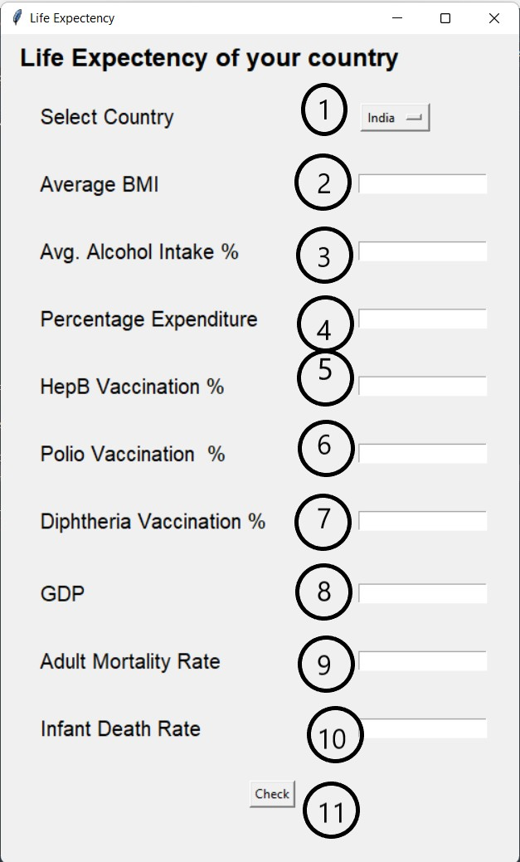Here, we have the main user interface for our project. The different Component of the design are:

* 1. Select Country Options

This is an option button that is used to select country of which you want to calculate life expectancy percentage.

* 1. Average BMI

This is a textfield that is used to take average bmi of country. As Bmi of a country plays an important role in life expectancy rate of that country.

* 1. Avg. Alcohol Intake

This is a textfield that is used to take average Alcohol Intake of

country. As Alcohol Intake of a country plays an important role in life expectancy rate of that country.

* 1. Percentage Expenditure

This is a textfield that is used to take Expenditure Percentage of country. As Expenditure of a country plays an important role in life expectancy rate of that country.

* 1. HepB Vaccination Percentage

This is a textfield that is used to take HepB Vaccination Percentage of country. As HepB Vaccination Percentage of a country plays an important role in life expectancy rate of that country.

* 1. Polio Vaccination Percentage

This is a textfield that is used to take polio Vaccination Percentage of country. As polio Vaccination Percentage of a country plays an important role in life expectancy rate of that country.

* 1. Diphtheria Vaccination Percentage

This is a textfield that is used to take diphtheria Vaccination Percentage of country. As diphtheria Vaccination Percentage of a country plays an important role in life expectancy rate of that country.

* 1. GDP

This is a textfield that is used to take GDP of country. As GDP of a country plays an important role in life expectancy rate of that country.

* 1. Adult Mortality Rate

This is a textfield that is used to take adult mortality rate of country. As Adult mortality rate of a country plays an important role in life expectancy rate of that country.

* 1. Infant Mortality Rate

This is a textfield that is used to take Infant mortality rate of country. As Infant mortality rate of a country plays an important role in life expectancy rate of that country.

* 1. Check button

This is a button that make the project run. On clicking the button, the prediction models are loaded. And Based on the inputs predicts the output i.e., the life expectancy of the country.

# User Interface and Output Interface

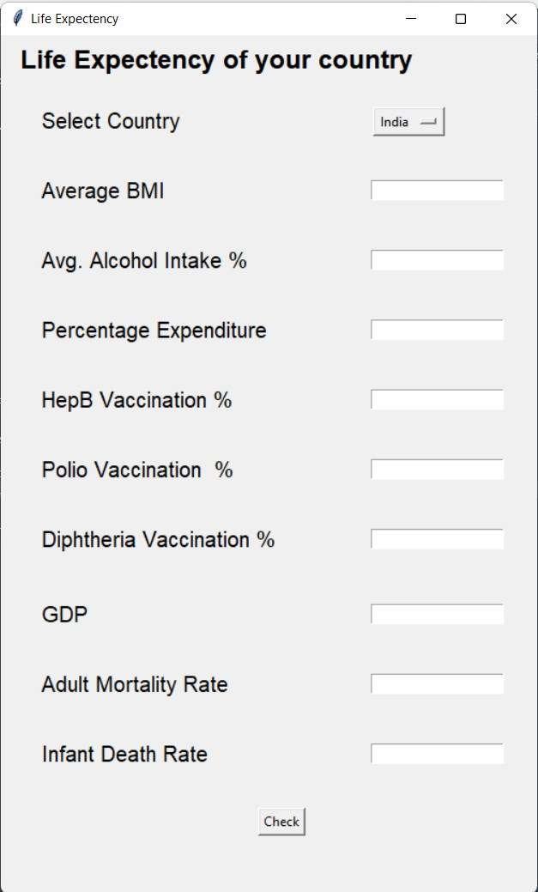



## Dataset Preview

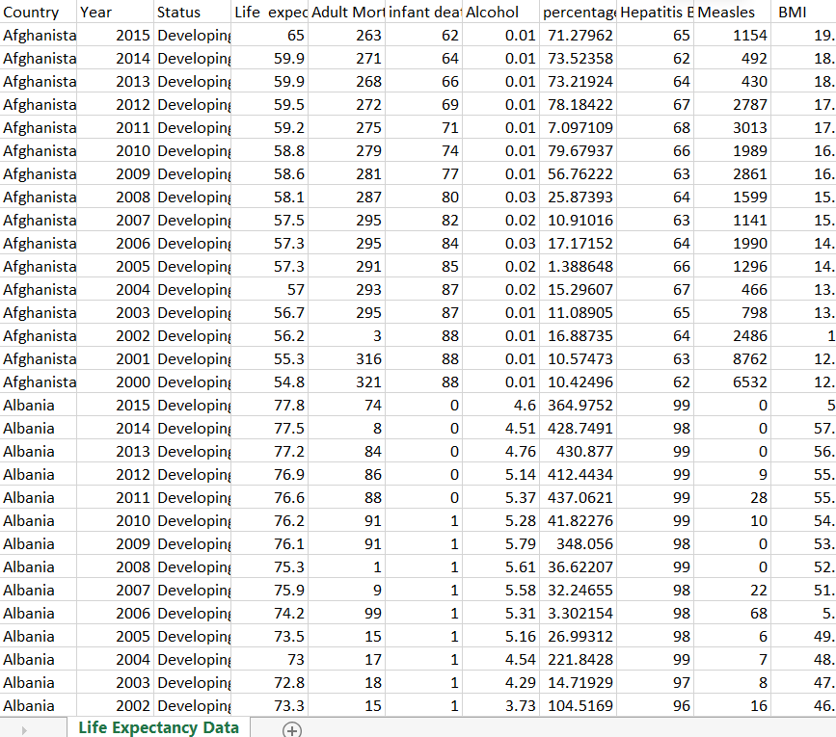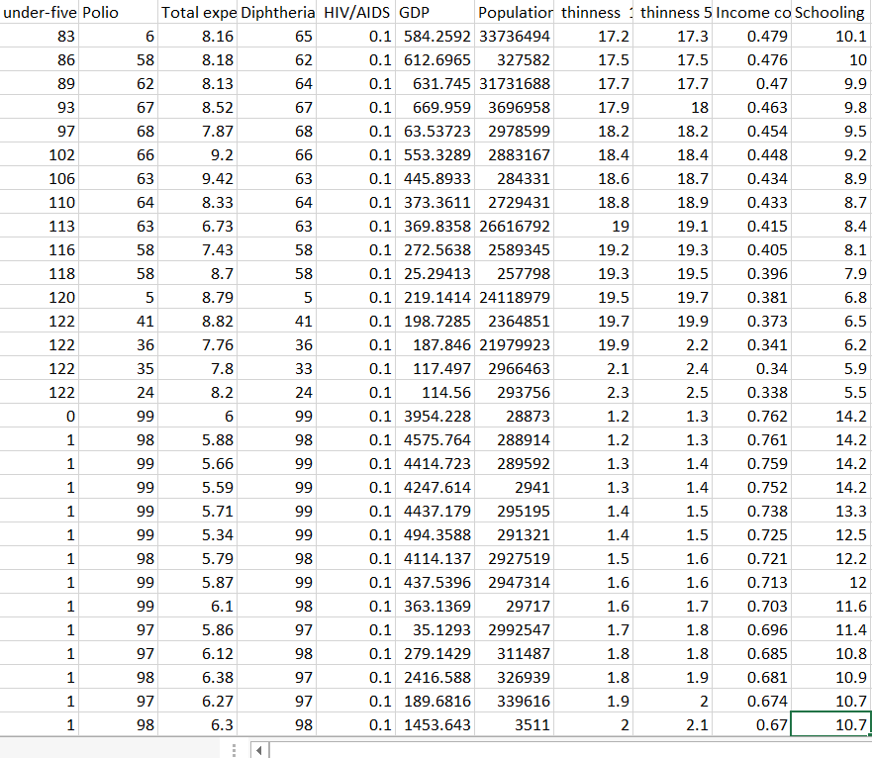

* There are 22 columns and 2940 rows in this dataset which includes country name, different parameter affecting the life expectancy rates and life expectancy rate of different years.

## Model Training Code

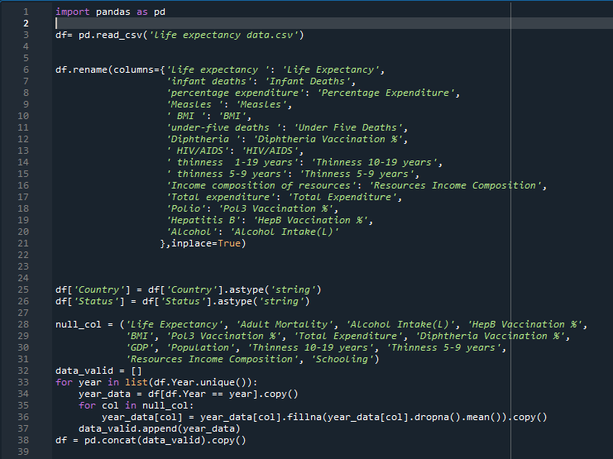

* This code segment is used to import the basic library (Line 1), load the csv file to the compiler (Line 3), renaming the columns of the dataset (Line 6), fixing the null data and dropping the useless data (Line 25 to Line 380).

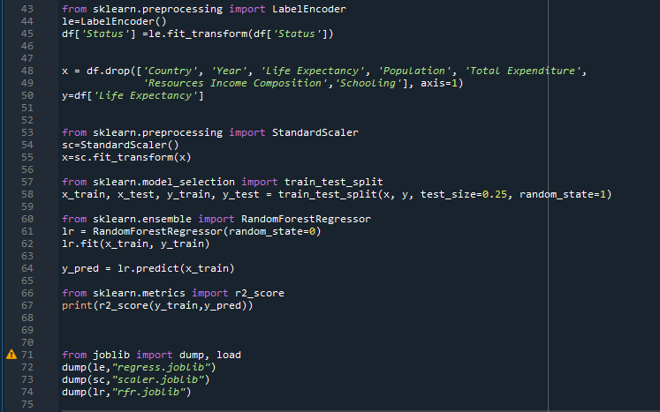

* The above code segment is used to import different library from scikit Learn packages.
  + Line 43-Importing Label Encoder-Converts the data into numeric value.
  + Line 53- Importing Standard scaler- Standardizes the encoded data
  + Line 57- Importing Train test split- used for splitting data for testing
  + Line 60- Importing Random Forest Regressor- algorithm used for final prediction.
  + Line 66-R2_score- checks the accuracy of prediction
* In this code segment we also drop the useless columns (Line 48) and import some functions from joblib library (Line 71)
* After all the process we Dump/save the models for the main project (Line 72 to Line 74)

## GUI and Event Code

* This code is used for the creation of the Gui using TKinter module, taking inputs from the user, loading the models create in previous code, getting data

from dataset as per the country selected and Finally Giving the output the prediction of life expectancy of the country selected based on the given inputs using the machine learning algorithm.

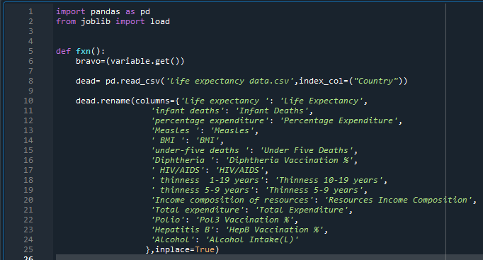

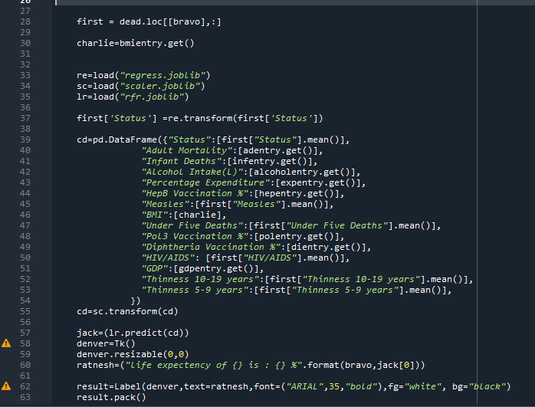

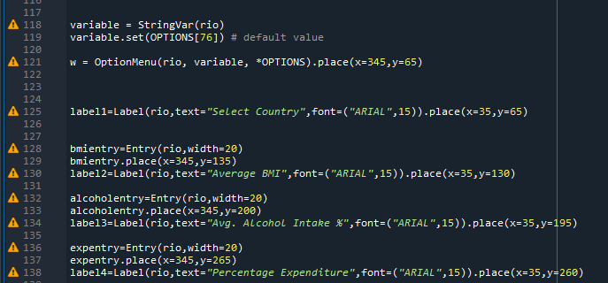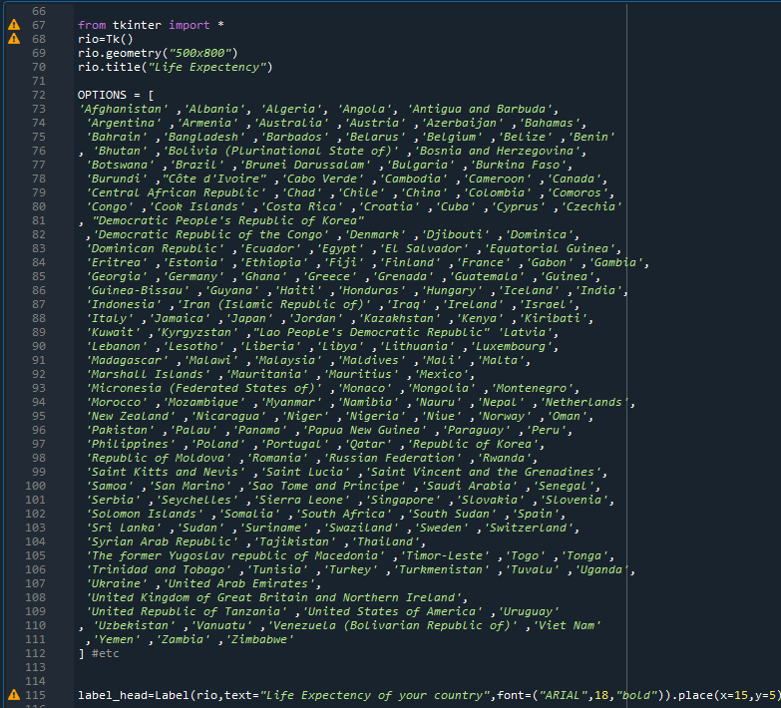

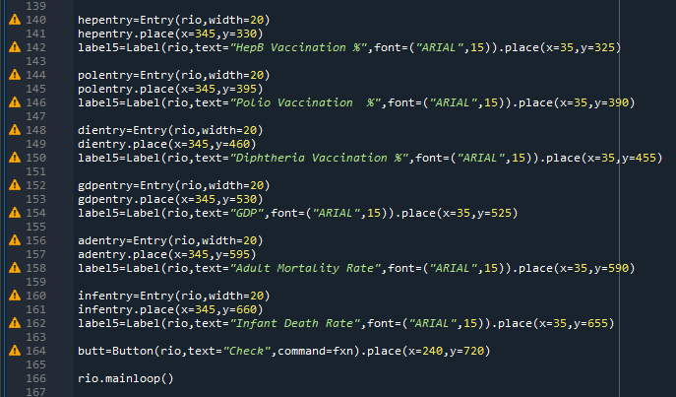

# User Manual

## Installing Python

Step 1: Select Version of Python to Install. Step 2: Download Python Executable Installer. Step 3: Run Executable Installer.

Step 4: Verify Python Was Installed on Windows. Step 5: Verify Pip Was Installed.

Step 6: Add Python Path to Environment Variables (Optional)

Step 7: Visit https://phoenixnap.com/kb/how-to-install-python-3-windows for more Details.

## Installing Spyder

Step 1: visit the site for spyder installation. Step 2: Click on download with Anaconda. Step 3: After the download, run the setup. Step 4: Follow the instruction.

Step 5: click launch button next to spyder on anaconda navigator

Step 6:Visit <https://learnpython.com/blog/how-to-install-python-spyder-ide/>for more

details

## Run the project

Step 1: Open the Spyder.

Step 2: open the lifeexpectancy.py file.

Step 3: select the directory and run the code file. Step 4: open the lifeui.py file and run.

Step 5: Give the input as per the fields and click check button

# References

* <https://learnpython.com/blog/how-to-install-python-spyder-ide/>
* <https://phoenixnap.com/kb/how-to-install-python-3-windows>
* Python.org
* Kaggle.com
* <https://scikit-learn.org/>

**END**